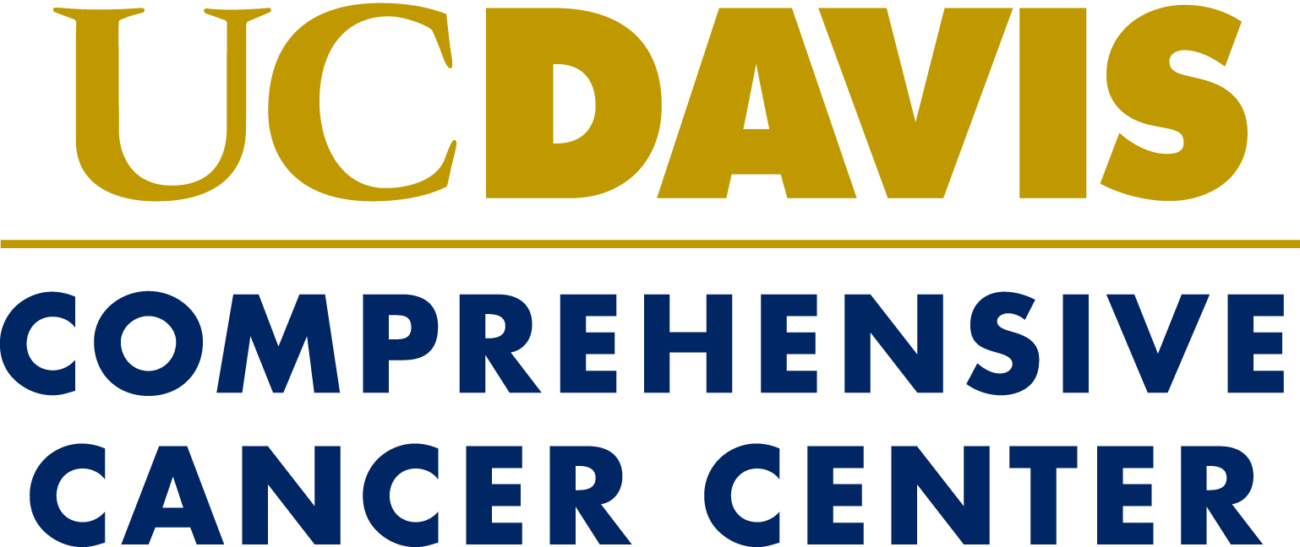

Molecular Oncology Program presents:

Crosstalk

Cancer Genetics meets DNA repair

Thursday February 28
2-6 pm
Life Sciences 1022

2:00-2:30 Wolf-Dietrich Heyer
Mechanism and regulation of recombinational DNA repair:
Model systems, mathematical modeling, and application in cancer therapeutics

2:30-3:00 Stephen Kowalczykowski
Functions of cancer suppressor proteins, BRCA2 and RAD51 paralogs, and defects associated with mutations

3:00-3:30 Neil Hunter
Insights into the mechanism and regulation of joint molecule resolution

3:30-4:00 Sheila David
Repair of Oxidative DNA base Damage: MUTYH-associated polyposis (MAP) and beyond

4:00-4:30 Coffee break

4:30-5:00 Hongwu Chen
Chromatin regulators in DDR and repair: from Yta to Ancca

5:00-5:30 Lifeng Xu
Understanding telomere defects associated with telomeric binding protein TIN2 mutations in Dyskeratosis Congenita

5:30-6:00 Luis Carvajal-Carmona
An update in the genetic susceptibility of cancer: back to DNA repair?

